Metal: Hellsinger to Hold Biggest Concert in Gamescom History!
Funcom and The Outsiders join forces with Gamescom and Level Infinite to dedicate an entire hall of the event to a massive live concert, with performances from the game’s celebrated metal musicians!
Oslo, Norway – August 4, 2022 – Metal: Hellsinger, the heavy metal rhythm shooter from publisher Funcom and developer The Outsiders, will take to the stage at Gamescom on 25 August, in the largest live concert ever seen at the event. Several of the game’s celebrated vocalists will perform their songs from the game, which are written by Swedish composer duo, Two Feathers. This epic joining of music and game starts at 7 p.m. CEST and will be streamed live for all to watch. Feast your eyes and ears on the trailer for this unique event now.
[Concert Announcement Trailer Direct DL] [ Concert Announcement Trailer YT]

After shooting past one million demo downloads and a rapid climb up the Steam wishlist, Funcom and The Outsiders turn it up to 11 by gathering an astounding number of the game’s metal icons to perform, including Matt Heafy (Trivium), Alissa White-Gluz (Arch Enemy), Mikael Stanne (Dark Tranquillity), Dennis Lyxzén (Refused/INVSN), and James Dorton (Black Crown Initiate).
The massive event is free and open to thousands of people, thanks to an entire hall being reserved for it. Even more will be able to witness the mayhem on the livestream, which will be detailed at a later point.
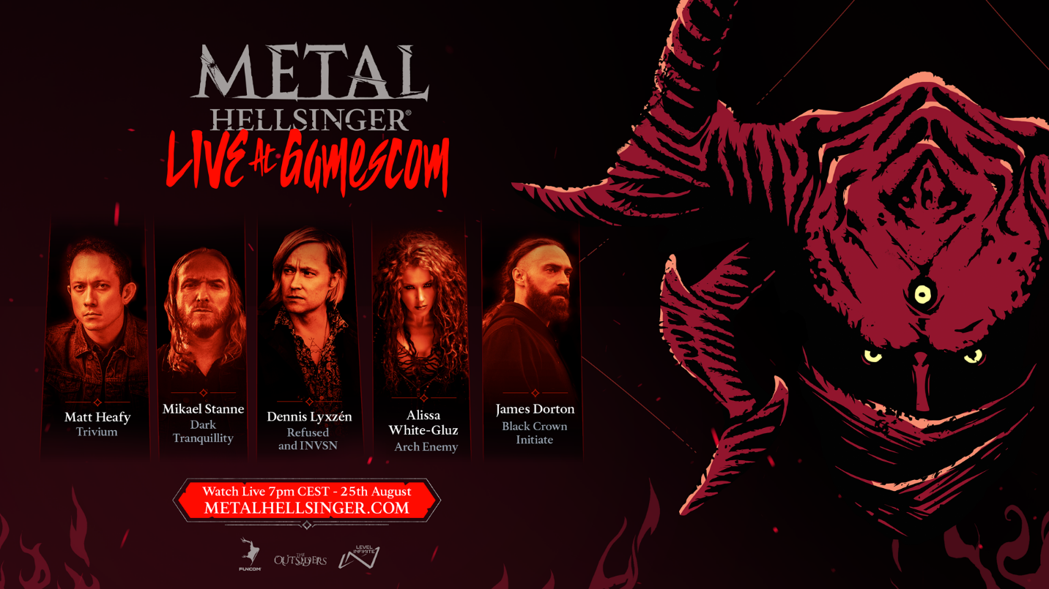
Those attending Gamescom have free access to the show, and the first 200 to enter will get a bagful of exclusive Metal: Hellsinger merch.
In Metal: Hellsinger, the better you slay to the beat, the more intense the experience gets, with the music unfolding in layers, until it culminates in full vocals blasting as you tear through demons. Dive headfirst into the fires and frost of the Hells in search of vengeance.
Metal: Hellsinger releases 15 September on Steam, PlayStation 5, and Xbox X|S. Pre-orders for consoles are available now, and the demo, which released to glowing responses, is available now on all platforms.

ABOUT FUNCOM
Funcom is a developer and publisher of online games for PC and consoles. Funcom has provided outstanding entertainment since 1993 and continues to expand its track-record of more than twenty released games. Titles include ‘Conan Exiles‘, ‘Secret World Legends, ‘Age of Conan: Hyborian Adventures’, ‘The Longest Journey', 'Anarchy Online', 'The Park', and 'Dreamfall: The Longest Journey'.
ABOUT THE OUTSIDERS
The Outsiders is a Funcom studio based in Stockholm, Sweden, consisting of ~30 creative people and four dogs. The Outsiders creates original games at high quality – specializing in first person games with unique gameplay mechanics and AAA-visuals. The team consists of industry veterans from DICE, Avalanche, King, Rovio, Fatshark, Starbreeze, Arrowhead, Goodbye Kansas, Machine Games, Guerilla Games, and many others - a good mix of the best talent from the many fantastic game development schools in Sweden. “We love games and we love making them. We hope that you will enjoy playing our creations!”

