Dune: Spice Wars gameplay revealed
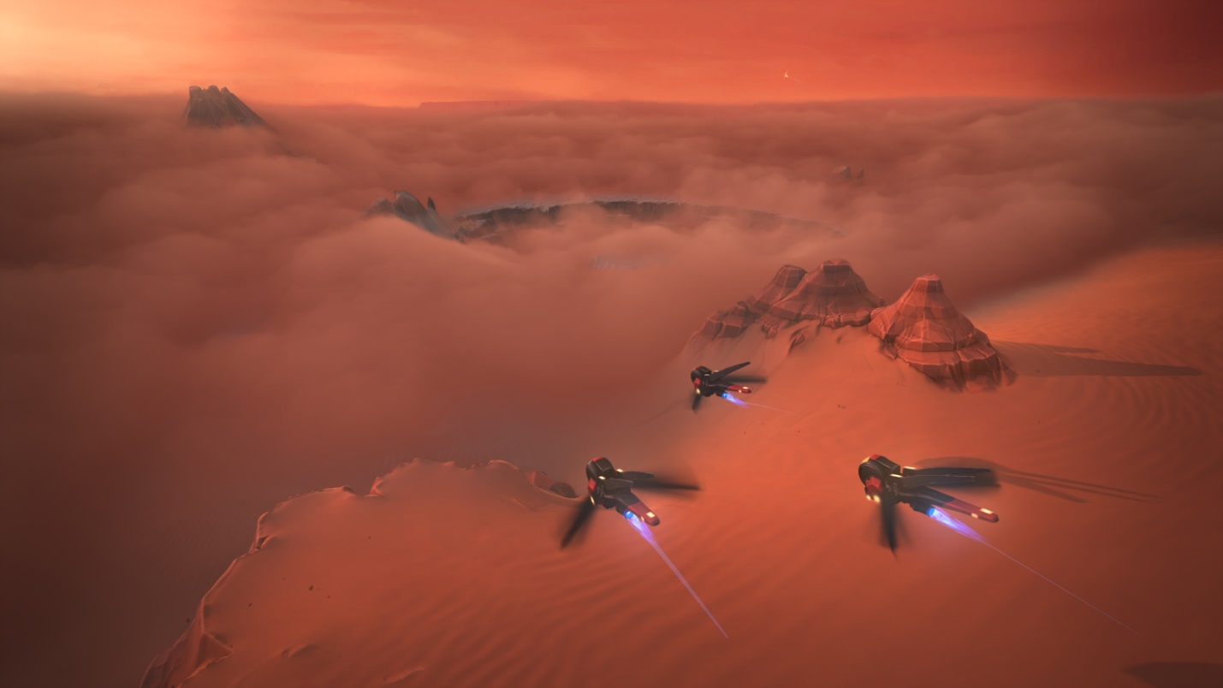
Developer Shiro Games and publisher Funcom reveal how the 4X/RTS plays.
OSLO, Norway – February 15th, 2022 – Announced at The Game Awards back in December 2021 with a cinematic trailer that made many Dune fans jump in their seats, Dune: Spice Wars is the first game in two decades that brings players back to the inhospitable world of Arrakis. Here, players must lead one of the great factions to power by controlling the most valuable and strategically important resource in the universe: spice. And as we all know: if you control the spice, you control the universe.
Today, developer Shiro Games and publisher Funcom released the first-ever gameplay trailer, providing a unique glimpse at how the game looks and plays.
TRAILER ON YOUTUBE | DOWNLOAD TRAILER | DOWNLOAD NEW SCREENSHOTS
“This is a universe we care deeply about, and there are millions of fans out there who feel the same strong connection with the source material as we do,” said Sebastien Vidal, CEO of Shiro Games, the studio that also developed the highly successful Northgard. “We’re die-hard Dune and strategy nerds, so this is very much a game by fans, for the fans.”
Following last year’s release of Denis Villeneuve’s epic film, that fanbase is bigger than ever.
Originally announced as a 2022 PC Early Access release, Shiro Games and Funcom today also announced that players can expect to make planetfall on Arrakis already this spring. The game will first launch into Early Access on Steam with several important updates planned, including the introduction of multiplayer, more factions, and a full campaign.
Besides publishing Dune: Spice Wars, Funcom is also developing an open world survival multiplayer game set in the Dune universe. The company holds the exclusive rights to develop and publish Dune games on PC and consoles.
For more information about Dune: Spice Wars, visit pr.funcom.com and dunegames.com.
---
ABOUT FUNCOM
Funcom is a developer and publisher of online games for PC and consoles. Funcom has provided outstanding entertainment since 1993 and continues to expand its track-record of more than twenty released games. Titles include ‘Conan Exiles‘, ‘Secret World Legends, ‘Age of Conan: Hyborian Adventures’, ‘The Longest Journey', 'Anarchy Online', 'The Park', and 'Dreamfall: The Longest Journey'. For corporate information please visit www.funcom.com.
ABOUT SHIRO GAMES
Shiro Games is an independent video game development studio based in Bordeaux, France. The team is made of talented and passionate developers who strive for excellence and are brave enough to make bold decisions on a daily basis. Titles include ‘Evoland’, ‘Evoland 2’, and the critically acclaimed RTS ‘Northgard’.

