A chopped-up Conan Chop Chop releasing today on PC and Nintendo Switch!
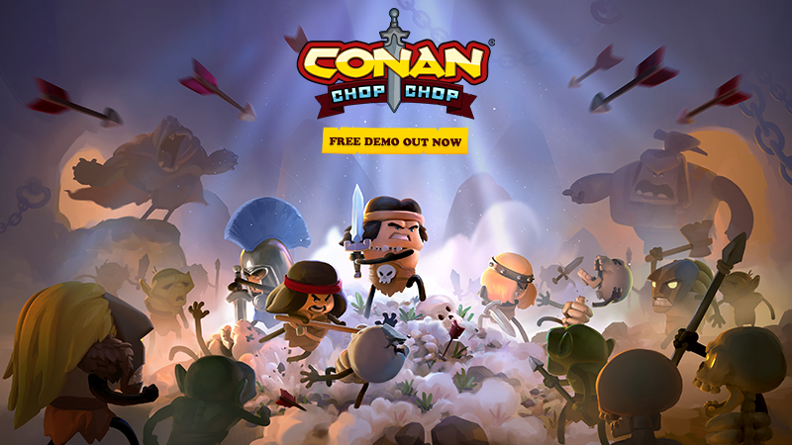
Do you have the chops to conquer this chopped-up demo of Conan Chop Chop that releases today on PC and Nintendo Switch? Well, what are you waiting for – get to the chop… no, wait… chop, chop!
OSLO, Norway – February 21st, 2022 – Funcom and Mighty Kingdom’s 1-4 player roguelite party game (with emphasis on party) is coming to PC, PlayStation, Xbox, and Nintendo Switch on March 1st. With its hilarious take on Conan the Barbarian’s world, Conan Chop Chop puts players into the leathery sandals of some of Hyboria’s greatest heroes as they battle to stop the treacherous wizard Thoth-Amon, evil incarnate and not a very nice guy.
Here’s the kicker: you can play it today! If you’re one of those who can’t wait to start chopping, you can get the chopped-up demo of the game and whet both your blade and your appetite of all things stickfigure Conan. From 10am PST/7pm CET today, the demo will be available on Nintendo Switch, and on PC as part of the Steam Summer Games Fest. Please note that the Nintendo Switch demo won’t be available in North and South America until February 25th.
Get the demo on Steam | Get the demo on Nintendo Switch
Check out the latest trailer, showcasing the 4-player co-op gameplay: YOUTUBE, DOWNLOAD.
Cleverly positioned as a roguelite party game, players get to throw themselves head-first into a 1-4 player multiplayer mayhem in both online and couch co-op. It has magically created maps, trillion of item combinations to loot, and an eclectic cast of curious critters ranging from self-replicating chickens to icky brain-spiders.
Conan Chop Chop will be priced at $14.99 on PC and $19.99 on console. Despite the barbaric source material, steps have been taken to get the game rated ESRB E and PEGI 7+, making it a great fit for parents looking for an excuse to spend more time with their kids.
For more information about Conan Chop Chop, visit pr.funcom.com and conanchopchop.com.
---
ABOUT FUNCOM
Funcom is a developer and publisher of online games for PC and consoles. Funcom has provided outstanding entertainment since 1993 and continues to expand its track-record of more than twenty released games. Titles include ‘Conan Exiles‘, ‘Secret World Legends, ‘Age of Conan: Hyborian Adventures’, ‘The Longest Journey', 'Anarchy Online', 'The Park', and 'Dreamfall: The Longest Journey'. For corporate information please visit www.funcom.com.
ABOUT MIGHTY KINGDOM
Since its formation in 2010, Mighty Kingdom has released over 50 games that have been downloaded more than 50 million times. Mighty Kingdom is one of the largest independent game developers in Australia. A growing team of more than 140 staff with significant experience across mobile and console platforms supports its clients to develop high-quality, successful games whilst driving Mighty Kingdom’s internal IP development.

