Conan Exiles: Age of Sorcery — Chapter 3 is Here!
The major free update in the Age of Sorcery arrives with new features and improvements for both new and veteran players alike.
Oslo, Norway – March 14, 2023 – Conan Exiles expands once again in the concluding third chapter to the Age of Sorcery, further enriching the open world survival experience by Funcom. Today, the game receives yet another large free update with a new paid Battle Pass and Bazaar shop cosmetic items to support it. Steel your nerves and charge into Golem Shaping, the Journey system overhaul, a new boss encounter, and more in the launch trailer.
Conan Exiles: Age of Sorcery — Chapter 3 Trailer
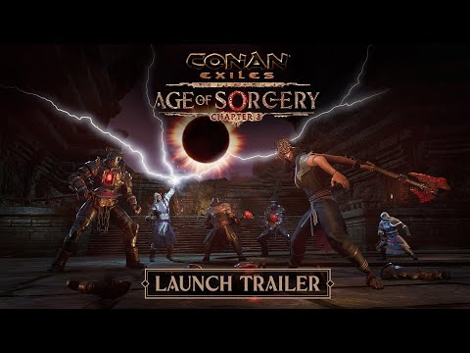
Chapter 3 is undoubtedly one the best times there has ever been for both new and veteran players to dive into or revisit Conan Exiles, thanks to the fully redesigned Journey System. Without sacrificing any of Conan Exiles’ openness and freedom, the Journey system allows you to easily find and explore any content in the game by simply selecting the Journey you wish to discover and following the tasks. Explore countless secrets, master every aspect of war, crafting, building, and earn valuable rewards with every Journey completed along the way.
Today’s update brings another brand-new feature: Golem Shaping. Explore the world to collect and assemble your own golem from various parts and materials to create a powerful guardian. Order it to destroy your enemies or, for the first time ever in Conan Exiles, have it autonomously harvest materials for you.
In today’s update, players will participate in the final epic confrontation that ends the Age of Sorcery. Experience a new boss encounter and face down Kurak, the one responsible for the spread of sorcery in the Exiled Lands.
After the Age of Sorcery comes to a close, a new age will follow. With Age of Sorcery, Conan Exiles embarked on a new way to provide both free and paid content, and the next Age will add another three major chapters of free content, accompanied by an array of themed cosmetics in the Battle Passes and Bazaar Shop.
Alone, co-op, or in full wild multiplayer, take the first step on this great new journey now on PC, PlayStation 4, Xbox X|S, Xbox One, and on both the PC and Xbox Game Pass.
ABOUT FUNCOM
Funcom is a developer and publisher of online games for PC and consoles. Funcom has provided outstanding entertainment since 1993 and continues to expand its track-record of more than twenty released games. Titles include ‘Conan Exiles‘, ‘Secret World Legends, ‘Age of Conan: Hyborian Adventures’, ‘The Longest Journey', 'Anarchy Online', 'The Park', and 'Dreamfall: The Longest Journey'. For corporate information please visit www.funcom.com.

