Conan Chop Chop is now available on PC and consoles!
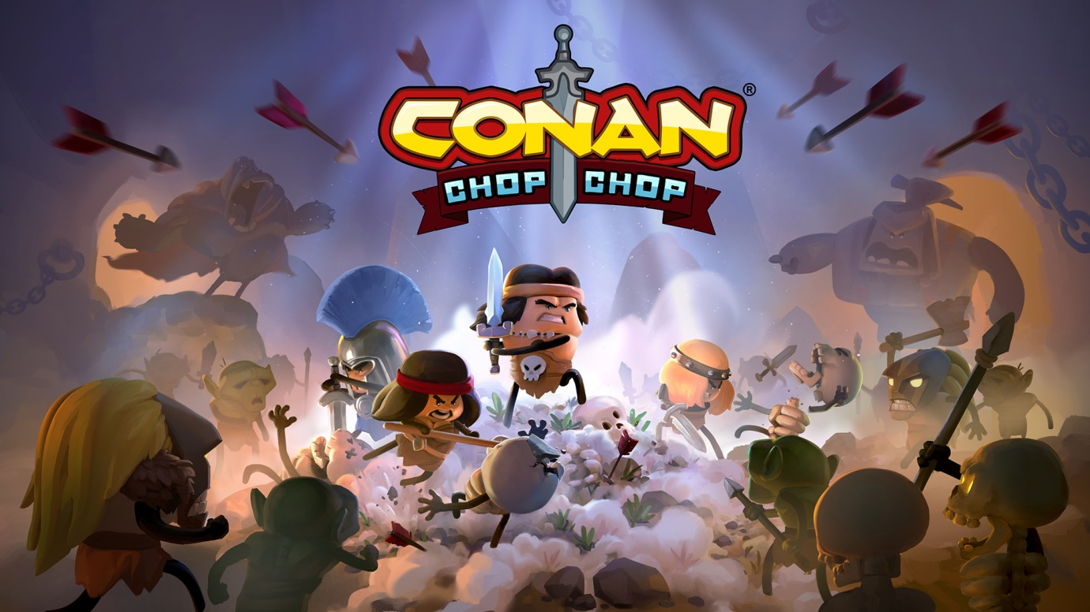
You can’t stop the chop! Charge into hilarious mayhem today on PC, Xbox One, PlayStation 4, and Nintendo Switch.
Oslo, Norway – March 1st, 2022 – Conan Chop Chop, Funcom and Mighty Kingdom’s 1-4 player co-op roguelite party game, releases today on PC and consoles, completing its journey from pretend April Fools’ joke to living legend. Either solo or in online and local co-op, step into the leathery sandals of Hyboria’s greatest thin-limbed heroes to put a stick in the evil machinations of the treacherous wizard Thoth-Amon. Witness this gloriously mad take on the world of Conan the Barbarian in today’s launch trailer.
“Our team set out to create a vision of Conan unlike any before it, and today we’re so excited to share it with the world,” says Kimbo Forrest, Creative Lead at Mighty Kingdom. “With the chaos turned to 11, we’ve condensed the brawny, ferocious spirit of the barbarian we all know and love into this shiny, party-sized Conan.”
LAUNCH TRAILER: YOUTUBE – DIRECT DOWNLOAD
Wield Conan’s final stick figure form as you chop, bonk, jab and loot your way through oodles of creatures and bosses, as diverse as they are peculiar (we’re looking at you, brain spiders). With four unique characters, magically generated maps, trillions of item combinations and skills to equip and upgrade, and a satisfying and responsive combat system, Conan Chop Chop is forged to please both veteran Conan fans and newcomers alike.
Conan Chop Chop is available now at $14.99 on PC and $19.99 on Xbox One, PlayStation 4, and Nintendo Switch. For anyone who wants to try the game out first, a free demo is available on Steam and Nintendo Switch. Despite the barbaric source material, steps have been taken to rate the game ESRB E and PEGI 7+, making it a great fit for parents looking for an excuse to spend more time with their kids.
For more information, visit www.conanchopchop.com or pr.funcom.com
A special message regarding the situation in Ukraine:
Like most of the world, the horrible events taking place in Ukraine are at the forefront of our minds. We want to take this opportunity to bring awareness to the humanitarian crisis and do our small part to help. Funcom will be donating 100,000 USD of the proceeds from Conan Chop Chop to the humanitarian efforts in Ukraine through the Red Cross.
Others can also donate to the relief efforts via the Ukraine crisis Red Cross website:
https://www.icrc.org/en/donate/ukraine
---
ABOUT FUNCOM
Funcom is a developer and publisher of online games for PC and consoles. Funcom has provided outstanding entertainment since 1993 and continues to expand its track-record of more than twenty released games. Titles include ‘Conan Exiles‘, ‘Secret World Legends, ‘Age of Conan: Hyborian Adventures’, ‘The Longest Journey', 'Anarchy Online', 'The Park', and 'Dreamfall: The Longest Journey'. For corporate information please visit www.funcom.com.
ABOUT MIGHTY KINGDOM
Since its formation in 2010, Mighty Kingdom has released over 50 games that have been downloaded more than 50 million times. Mighty Kingdom is one of the largest independent game developers in Australia. A growing team of more than 140 staff with significant experience across mobile and console platforms supports its clients to develop high-quality, successful games whilst driving Mighty Kingdom’s internal IP development.

