Conan Exiles: Age of Sorcery — Chapter 2 is live!
The major update brings several free features and improvements alongside unique cosmetics through Twitch Drops and the new Battle Pass.
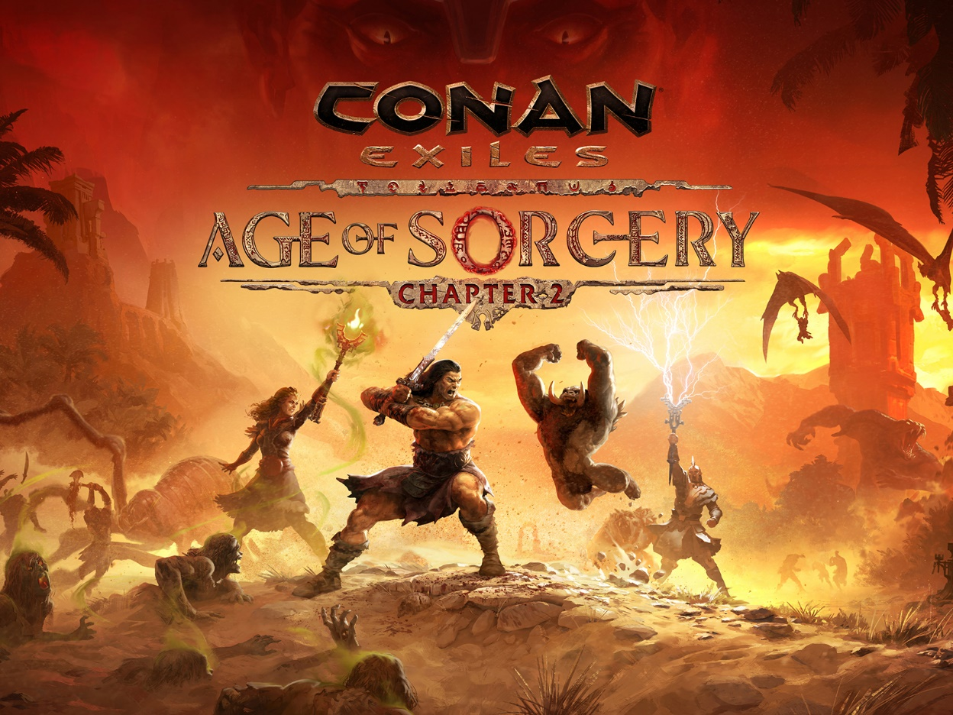
Oslo, Norway – December 6, 2022 – Conan Exiles receives its first major update following the monumental shift that came with Age of Sorcery, filling the game’s vast and savage wilderness with even more activities and danger. The free update arrives at the same time as a trove of new cosmetics that can be purchased through the new Battle Pass or in the Bazaar item shop. Feast your eyes on the abundance of new content in the Launch Trailer!
YouTube trailer
Funcom is also excited to announce three new Twitch Drops, running from today until January 3rd, letting players acquire two wall ornaments and the beautiful and festive Crested Lapdog pet simply by watching Conan Exiles streams on Twitch. Players need only link their account to Twitch through a button in the in-game menu to get started.
The arrival of sorcery has shaken the foundations of the Exiled Lands. Strange rituals are performed everywhere as sorcerers run rampant with the newfound power. In Chapter 2, players will come across the camps of Khitan Headhunters in both the Exiled Lands and The Isle of Siptah. To understand the new sorcery that has burgeoned, they will task you with hunting down and bringing them sorcerer NPCs across the lands. Although their skull will do, living bodies provide much higher rewards, including a new armor set.
On their journeys, players will also run into the new Witch Hunt Encounter, where they can interrupt the powerful rituals of one of four different boss-level sorcerers. These sorcerers cannot be taken alive, but their skulls can also be brought to the Khitan camps for a big payout.
Arriving in parallel with the free update, a huge assortment of new paid cosmetics is available through the Bazaar item shop and new Battle Pass, including the extended Stormglass building set, new armor and weapon looks, new pets, unique decorations, and more!
Conan Exiles continues to expand its wealth of content and gameplay with each free update. Players can experience Chapter 2 now on PC, PlayStation 4, Xbox X|S, Xbox One, and on both the PC and Xbox Game Pass.
ABOUT FUNCOM
Funcom is a developer and publisher of online games for PC and consoles. Funcom has provided outstanding entertainment since 1993 and continues to expand its track-record of more than twenty released games. Titles include ‘Conan Exiles‘, ‘Secret World Legends, ‘Age of Conan: Hyborian Adventures’, ‘The Longest Journey', 'Anarchy Online', 'The Park', and 'Dreamfall: The Longest Journey'. For corporate information please visit www.funcom.com.

